Prepared for
Federal Health Architecture Program
Results of the Assessment of the Federal Health Information Model (FHIM)
December 26, 2012
Version 1
The views, opinions, and/or findings contained in this report are those of The MITRE Corporation and should not be construed as official government position, policy, or decision unless so designated by other documentation.
This document was prepared for authorized distribution only. It has not been approved for public release.
© 2012, The MITRE Corporation. All Rights Reserved.
MITRE
7515 Colshire Drive
McLean, VA 22102

Executive Summary
At the request of the Federal Health Architecture (FHA) Program within the Office of the National Coordinator for Health IT (ONC), MITRE performed an assessment of the Federal Health Information Model (FHIM) initiative utilizing the FHA Initiative Assessment tool completed in FY12 to assure that investments of FHA resources are based on objective data and aligned with the goals of the FHA Program. MITRE took the basic Initiative Assessment process, and tailored it to the FHIM, resulting in three components as follows:
- An FHA Alignment Assessment, which examines initiative alignment with FHA goals, objectives, priorities, and requirements;
- An Initiative Production Assessment, which evaluates the management, structure, and readiness of mature initiatives to be used by FHA Partners; and
- A Technical Evaluation, focusing on model quality, approach, and viability of implementation. This section pairs with the assessment tool’s ability to be tailored to the specifics of the initiative being assessed.
Each of the three areas consisted of a number of red, yellow, or green ratings corresponding to whether or not the area displayed problems and unmitigated risks, and their severity. The complete details of the assessment process that was used are available in a document entitled “FHIM Assessment Process-R3” that was made available to the FHA Managing Board several weeks prior to the beginning of the assessment.
Table 1 FHIM Assessment Criteria Sorted by Assessment Ratings
 |  | 
- Alignment with FHA Strategic Goals & Objectives  - Support for FHA Technical Goals  - Model Quality | - Support for FHA Stakeholder Priorities  - Aligns with other FHA Initiatives  - Design  - Alignment with FHA EA  - Ability to Implement | - Alignment with Requirements  - Testing  - Management  - User Documentation
The assessment found a number of positive points about the FHIM; in discussions with stakeholders, those who understood the Model-Driven Architecture (MDA) approach were supportive of it, and felt that it held the promise to make progress with health information interoperability. The model also reflected substantial detailed and high-quality work with subject-matter experts, and was found to be of good general quality. Finally, there was general agreement that the high-level goals for FHIM were good things to pursue, and represent areas of need for the government.
The assessment found a number of key risks and issues, including:
- The assessment was not able to identify any FHA Partners with plans to implement FHIM in the manner of the goals stated by FHIM initiative leadership;
- FHA and ONC leadership have stressed the importance of demonstrating FHIM’s value to the S&I Framework (S&I). At present, it does not appear that FHIM is on a path that will result in its use within the S&I initiatives;
- The assessment was unable to locate documented requirements, and the FHIM scope appears to be all health information, raising concerns about how FHA will know when it is complete;
- Related to initiative management, the assessment noted numerous stakeholder concerns with FHIM’s ability to articulate its value proposition;
- FHIM’s present management presents substantial risks, because it is not currently receiving input or priorities from the FHA Partners, and its management structure appears to stem from a now-defunct 2009 FHA Standards Program.

Table of Contents

1 Introduction 1
2 FHIM Goals 1
3 Summary Results: Score Cards 2
4 FHA Alignment Assessment 3
4.1 Alignment with Strategic Goals and Objectives 3
4.2 Support for FHA’s Technical Goals 3
4.3 Alignment with Requirements 4
4.4 Support for FHA Stakeholder Priorities 4
4.5 Initiative Aligns with Other FHA Initiatives 4
5 Initiative Production Assessment 5
5.1 Design 5
5.2 Testing 6
5.3 Management 7
5.4 User Documentation 7
6 FHIM Technical Assessment 8
6.1 Technical Overview 8
6.2 The Purpose of Models 8
6.3 MDA Primer: What is it, what is the Value Proposition? 9
6.4 What it Means: Comparing MDA to the Alternative 10
6.5 Model Quality 11
6.6 Alignment with the FHA EA 12
6.7 Ability to Implement 12
7 Key Risks and Issues 12
8 Conclusions 13
Appendix A Interviewed Stakeholders 15
Appendix B Score Card Worksheet 15
List of Acronyms 19

List of Tables
Table 1 FHIM Assessment Criteria Sorted by MITRE Assessment Ratings i
Table 2 FHA Alignment Assessment Criteria 2
Table 3 Initiative Production Assessment Criteria 2
Table 4 FHIM Technical Assessment Criteria 2
Table 5 FHIM Stakeholders Interviewed as Part of this Assessment 14
Table 6 FHIM Assessment Worksheet 14

List of Figures
Figure 1 Listing of FHIM Domains, with progress information 6
Figure 2 NwHIN Portfolio Interoperability Stack 8
Figure 3 Platform Independent Models, and their Transforms 9

Introduction
The Federal Health Architecture (FHA) is an E-Government Line of Business initiative managed by the Office of the National Coordinator for Health IT. FHA was formed to coordinate health IT activities among the more than 20 federal agencies that provide health and healthcare services to citizens.
The FHA Partners are helping build a federal health information technology environment that is interoperable with private sector systems and supports the President’s plan to enable better point-of-service care, increased efficiency and improved overall health in the U.S. population.
In FY2012, MITRE developed an FHA Initiative Assessment tool for assessing FHA initiatives in a consistent manner and to provide the FHA Managing Board with data it could use for making investment decisions about FHA initiatives.
At the request of the FHA Program, MITRE applied the assessment approach to the Federal Health Information Model (FHIM) initiative. This document outlines the results of the assessment, which has three components:
- An FHA Alignment Assessment, which examines initiative alignment with FHA goals, objectives, priorities, and requirements;
- An Initiative Production Assessment, which evaluates the management, structure, and readiness of mature initiatives to be used by FHA Partners; and
- A Technical Evaluation, focusing on model quality, approach, and viability of implementation. This section pairs with the assessment tool’s ability to be tailored to the specifics of the initiative being assessed.
The outcome of the assessment is a series of score cards for FHA decision makers, an identification of key risks, and recommendations on FHA investment.

FHIM Goals
In order to guide the evaluation of specific criteria for a particular project, the assessment team solicited inputs on the project’s key goals and aspirations. Interviews with the Project Director about the FHIM provided two key goals, which will be used as a point of reference:
- FHIM is intended to be a logical information model harmonized across all FHA Partners that could be used as the information or data layer in an agency’s enterprise architecture; and
- FHIM is meant to be the high-level model used to drive a Model-Driven Architecture (MDA) approach to implementing standards.
These goal statements contain specific language which can benefit from explanation, to clarify what FHIM is trying to accomplish:
In the first goal, “logical information model” refers to FHIM’s construction as a high-level model that does not contain implementation details. This is in contrast to a “physical model” which contains details that tie a model to a particular implementation technology such as XML. The first goal’s reference to a “harmonized model” means that the concepts in the model are common to the FHA Partners, and represent a consensus of what a given information concept (like “Healthcare Provider”) really mean. Finally, for the model to be used as the information or data layer in an agency’s Enterprise Architecture (EA), it might be used as a mapping artifact. If FHA Partners mapped each of their systems into the FHIM according to the information the partner’s system provided, the EA could provide a consolidated view, for example, of all systems which contained “Healthcare Provider” information, and which details they contained.
The second goal has to do with automatically generating data models, programming code, documentation, and other technical artifacts. The FHIM goal is for its “logical information models” to be used as the input to a technical process that could produce models suitable for implementing data exchanges. This topic is quite complex, and is covered in more depth in a later section titled “MDA Primer: What is it, what is the Value Proposition?” If this goal is successful though, it involves a change in the way FHA Partners build their data exchanges, away from building particular schemas to exchange particular data sets, and towards more co-maintenance of the “logical information model”.

Summary Results: Score Cards
The summary score cards presented in this section represent roll-ups of a number of individual assessment criteria. The detailed assessment criteria can be found in Appendix A, and the FHA Initiative Assessment Process (R3) document. Each of the areas in the table below that received a red, yellow, or green rating corresponds to a number of sub-criteria located in the assessment process document.
While the Assessment Process document contains a more detailed treatment of how the red, yellow, and green are to be interpreted, for quick reference red refers to areas where there are substantial unmitigated problems or risks; yellow refers to areas where some unmitigated problems or risks, and green refers to areas that are on track, or otherwise do not present any unmitigated risks.
Table 2 FHA Alignment Assessment Criteria
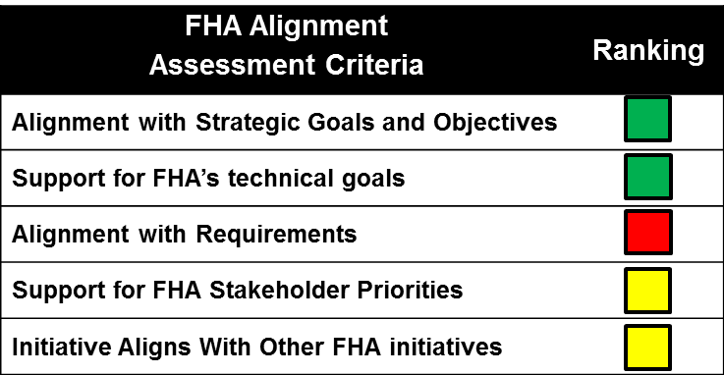
Table 3 Initiative Production Assessment Criteria
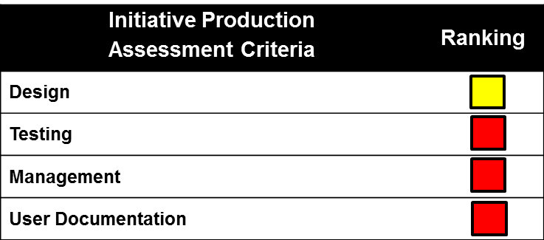
Table 4 FHIM Technical Assessment Criteria
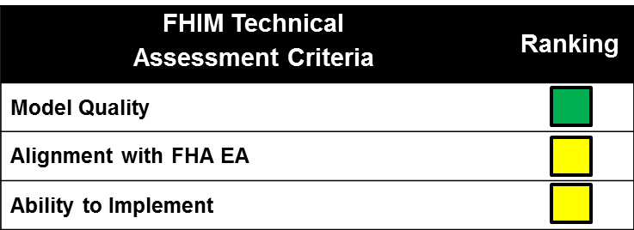
The following sections break each of these three tables down into more detail. For each row in the score card tables, there is a corresponding section which describes the key findings and process that went into assigning the rating of red, yellow, or green.

FHA Alignment Assessment
The FHA Alignment Assessment considers whether FHIM is appropriately aligned with the FHA organization’s emerging goals, objectives, priorities, and requirements.

Alignment with Strategic Goals and Objectives
FHIM aligns well with the FHA Strategic Plan Revised Draft dated November 29, 2012. Specifically, FHIM aligns with Goal 2, which is to “Encourage adoption of interoperability specifications, resulting in active data exchange in the federal health community”. The dual focus on generating implementation guides, as well as supporting EA work aligns with the following objectives in the strategy:
Assessment
- Objective 2.1: “Improve exchange of Health Data among the Federal Government (…)”; and
- Objective 2.2: “Encourage Adoption of Interoperability Specifications (…)”.

Support for FHA’s Technical Goals
Assessment
The FHIM does reuse existing interoperability specifications such as the National Information Exchange Model (NIEM) and the Clinical Document Architecture (CDA). FHIM also provides a potential enabling technology for interoperability, in the form of methods for generating implementation guides, and harmonizing data models.
In addition, the potential ability to map multiple different implementation standards to a common standard is an approach that has promise. In interviews with stakeholders, several of them who did understand the MDA approach indicated some support for it as a long-term objective.
While the FHIM project does not comply with any present privacy and security policies, this was listed as not applicable for FHIM because it is a high-level information model not intended for direct implementation; downstream implementers will still be required to adhere to those policies.

Alignment with Requirements
Assessment
The assessment team was not able to locate any documented requirements for the FHIM through interviews, or a review of the project archive documents. As the FHA Managing Board has only recently become the governing authority for FHIM, the FHIM initiative has no approved requirements through FHA or any requirements traceability matrices that could be located.
Based on scope as it has been stated in management presentations ”requirements creep” is a major risk for FHIM. Because the scope of the FHIM is essentially the entirety of health information, it is difficult to establish what would be a complete list of requirements or health domains. There also does not appear to be any metric for completeness of the model with respect to its stated goals.
As a result, FHIM can be said to be complete with respect to the needs of a particular sub-domain, or with respect to the needs of a particular data harmonization challenge, but the model itself will never be completed. As time goes on and domains evolve, model sub-domains will inevitably require updates and elaboration.

Support for FHA Stakeholder Priorities
Assessment
The assessment team noted that FHIM has made efforts to leverage existing ONC initiatives such as the Standards and Interoperability (S&I) Framework. FHIM’s work with S&I has come in two forms:
- Discussions about using FHIM as an over-arching logical information model for many S&I initiatives; and
- Participation in the Public Health Reporting (PHR) initiative.
In the case of the PHR initiative, the outcome reported by stakeholders was “data collected from more than 30 places, which represent major activities for public health. FHIM was used as the foundation for harmonization between user stories, models, and other artifacts”.
The FHIM model has recently achieved a state where users can begin to evaluate its use for generating implementation guides, but after several years of investment the team cannot point to any concrete instances of interoperability that have resulted from the use of FHIM. In interviews with FHA Partners, some interviewees expressed that the model was untested, and that while the goals were appropriate, they had yet to be demonstrated.

Initiative Aligns with Other FHA Initiatives
Assessment
In this area, the assessment team found mixed results. This assessment area was meant to apply to many different potential FHA initiatives. While FHIM has aligned very well with a number of different information exchange standards and ways of representing values and terminology, it is not yet fully aligned with the EA modeling activities happening within FHA. While all of our information indicates that there is no fundamental roadblock that prevents FHIM from aligning with the FHA model, that alignment has not yet taken place, and the FHIM artifacts are hosted on a separate project site, apart from the FHA EA artifacts, and requiring separate login and password.
Within the FHA organization, there has been discussion of using the FHIM as part of the “data layer” of a Federal Health Architecture product, but this has not yet been realized.

Initiative Production Assessment
The focus of the Production Assessment was to determine if FHIM is mature enough for use in support of health interoperability goals across the FHA community of over twenty Federal agencies. To help determine its current maturity, FHIM was studied in the areas of overall design, testing, management, and user documentation. The findings in each of these areas are described in the following sections.

Design
Assessment
The actual products of FHIM are a comprehensive set of information and terminology standards to support interoperability in the Federal health community. There is sufficient information describing what FHIM intends to be and how it supports the interoperability goals on the FHIM public website and their internal repository of artifacts. FHIM is currently comprised of a number of health information domains with a quarter of them documented as complete to date, as show in Figure 1.
The FHIM design represents an approach where the size of the healthcare space is broken down into different “domains”, each of which can be attacked separately, all while retaining a common design approach for the overall model. This represents a good design approach, given the enormity of the scope.
The primary aspect of the design that resulted in a yellow rating in this area is that the design is not at present focused on operational problems of the FHA Partners. The selection of which domains to model appears to be driven by the availability of SMEs more than key interoperability hurdles within the federal community. Additionally, the FHIM design strongly resembles a “top-down” approach. While a top-down approach is understandable for a high-level information model, the design does not appear to be tempered by “bottom-up” considerations of what the FHA Partners implement today, or why.
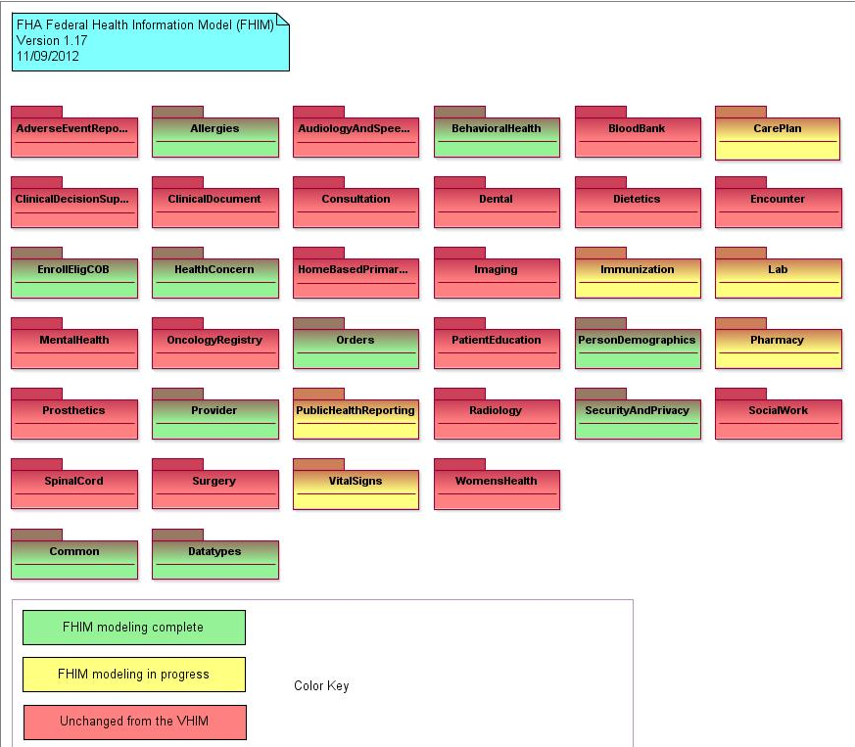
Figure 1 Listing of FHIM Domains, with progress information
FHIM holds weekly working sessions with its members focused on information modeling, terminology modeling, and information exchange designs. In terms of how the priority order of the domains are determined, FHIM is presently in a period of transition between governance structures; the FHA Managing Board is intended to provide feedback to FHIM on which areas are of interest, but to date has not provided substantive feedback on prioritization of domains.

Testing
Assessment
Other than the FHIM Model-Driven Architecture Prototype, there is no evidence that any or all of the components of FHIM have been tested for an existing information exchange. Testing with a particular information exchange would be important to demonstrate progress towards the second goal listed in FHIM Goals above. The Prototype document dated April 2012 provides a description of how FHIM can be used as a platform independent model in combination with a set of factors to produce information exchanges. While the paper discusses the approach for the prototype using a component of Standards and Interoperability Framework and lessons learned, the description seems to be more oriented towards demonstrating a proof of concept. The assessment process did not reveal any description of a running data exchange based on the FHIM that is in operation today.
The assessment team was not able to locate other testing documentation in the FHIM repository of information, nor are there any follow-on outcome descriptions of the model-driven approach repeated with another S&I initiative.
Another type of testing that would be helpful for FHIM would be testing for appropriate semantic coverage, requiring specific use cases and examples which the model can be evaluated against for satisfactory coverage. The FHA Managing Board has discussed this in the past FHIM “model evaluation” with similar goals, but as yet this evaluation has not taken place.

Management
Assessment
The FHIM effort seems to be managed with minimal structure. Although FHIM carries a charter dating back to 2009 referring to an FHA Standards Program, the original program under which FHIM was chartered is not presently in operation.
In the current governance structure, FHIM is recognized as an initiative, but few decisions are formally made concerning it by the FHA Managing Board. The FHIM effort’s previous alignment with now-inactive FHA Standards Program places it in an unusual position with respect to management.
With regard to planning, organizing, staffing, and controlling FHIM, the management framework does not seem apparent, other than weekly teleconferences focused around technical aspects of continuing modeling efforts. In particular, governance of the actual model, including versioning, change control, and other aspects do not appear to be documented.

User Documentation
Assessment
Documentation to help users understand how to use FHIM is limited. For all user roles (e.g. data modeler, architect, etc.), there is a public web site that provides information describing FHIM purpose, goals, and domains. Other documentation available on the internal website for FHIM includes:
- “FHIM Model-Driven Architecture Prototype” dated April 2011 provides a description of how FHIM can be used as a platform independent model in combination with a set of factors to produce information exchanges. The paper provides an understanding of how FHIM can be used to produce information exchanges.
- “Information Modeling Project Terminology Modeling Process” dated September 2012 provides a description of the modeling process itself, but does not necessarily provide an explanation on how to use FHIM.
- “Information Modeling Project Modeling Process Style Guide” dated November 7 2012 is currently a work in progress. The audience for this document is largely information modelers.
Most FHIM users interviewed learned the model by “diving in” and by participating on phone calls and in activities; none referred to the available documentation as a source of information for them as they began. Training documentation, or the existence of training plans to help train new users of any role (data managers, modelers, project managers, etc.) into the FHIM initiative could not be located.
The observed lack of user documentation should be considered a risk, as it limits the number of users who can learn and understand FHIM, and subsequently apply it to their agency’s challenges.

FHIM Technical Assessment
The Technical Assessment is intended to answer specific questions about the quality of the FHIM technical products, to include the quality of the produced models, the alignment with the FHA EA, and the ability to implement actual exchange descriptions using the FHIM.

Technical Overview
During interviews with the various stakeholders, it was found that understanding of the model-driven approach and model-driven architecture (MDA) is not common. Because these concepts are important to understanding the second FHIM goal listed at the beginning of the assessment, the following section presents a brief primer on MDA, to help ground a discussion of where FHIM is and what options FHA has moving forward.

The Purpose of Models
When data is exchanged, participants must be able to interpret the meaning of each element – the semantics, (e.g., what is a Secondary Diagnosis), the valid values for each element (e.g., a reference to a taxonomy of medical problems), content structure over those elements (e.g., HL7 C32 message, as a tree), the code sets (e.g. the coded value “54131-8” refers to “Gender” under LOINC) and the representation of element values and of structure (e.g. dates may have only two-digit years, and the entire message is encoded in XML).
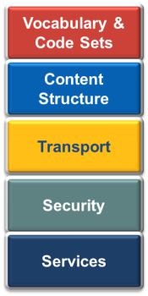
Data and information models focus in this area of the Interoperability Stack
Figure 2 NwHIN Portfolio Interoperability Stack
The purpose of a data or information model is to capture commitments on the semantics and structure of data elements and coded data items. Models serve as the documentation of the common agreement between exchange participants. Models alone are not useful; they act as the necessary foundation for other work. When various parties want to exchange information, they must build software (services and security) to effect that exchange, i.e. to send data over the wire (the transport layer), and have it received on the other end. Data or information models typically refer only to the top two layers of the NwHIN Portfolio Interoperability Stack pictured in Figure 2 above.
A model’s value is proven by pairing it with other technologies that satisfy transport, security, and service considerations, and then applying it to one or more information exchange scenarios. That is, value comes from using the model in a data exchange.

MDA Primer: What is it, what is the Value Proposition?
FHIM employs a Model Driven Architecture (MDA) approach with Unified Modeling Language (UML) 2.x as the modeling language. The FHIM itself is a “Platform Independent Model” (PIM), which is used to harmonize interoperability requirements and to promote a consistent approach to health IT standards. Here, the term “platform” refers to a technology platform, or a particular way of implementing information exchanges, such as via eXtensible Markup Language (XML).
In order to use the FHIM though, one needs more than just a PIM, because not all semantics are in the PIM. The value of the PIM’s harmonized interoperability requirements come from their use in a series of Platform Specific Models (PSM). One of the design goals in MDA is to separate the semantics which are independent of the underlying technology, from those which are dependent on the technology, hence the distinction between PIMs and PSMs. The semantics of health care providers, for example, would capture the fact that they have an address in the PIM, because that does not depend on any underlying technology. Additional details of how the address is represented or validated, on the other hand, might be in the PSM.
Examples of PIMs in the FHIM include Clinical Document Architecture (CDA) and the National Information Exchange Model (NIEM). Ultimately, to exchange information users must choose some technology, and eventually they will need to work with PSMs. The MDA approach then includes technical provisions for how PSMs can be generated by software. The value of generating these PSMs by software is that modelers can build and maintain a platform-independent model as the semantics of their domain changes, and have a way of getting back to an implementable PSM without considerable rework. This increases the efficiency of creating models as technologies evolve. For the FHA Partners, this would mean the potential to have some “insulation” from the technical change that is inherent in new standards which come along from time to time, and new versions of existing standards that develop.
To get to a PSM from a PIM, requires developing a Platform Definition Model (PDM) that defines the transformational rules. Those transformational rules are written in Query/View/Transformation (QVT) language. The PDM or PIM may also contain constraints for mandatory/optional field type rules or conditional field type rules, documented through the Object Constraint Language (OCL). The transformation process is illustrated in the figure below, taken from the FHIM presentation to the July 2012 Architecture & Modeling Working Group meeting.
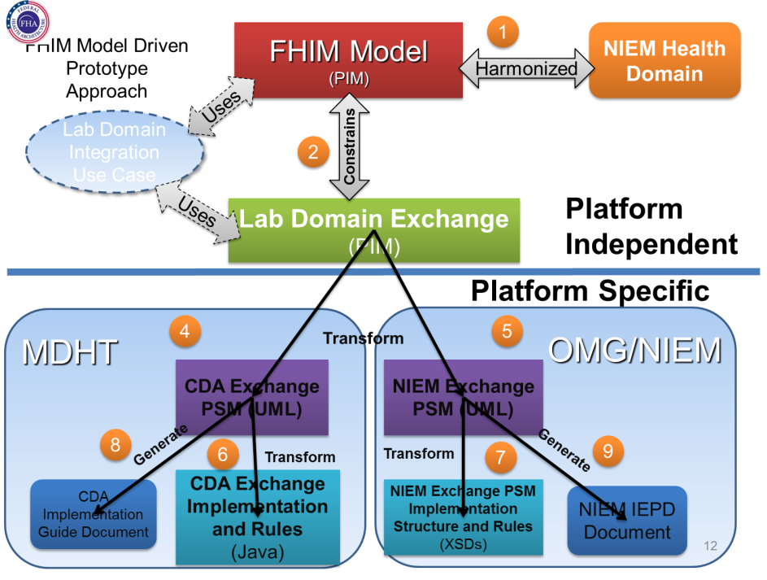
Figure 3 Platform Independent Models, and their Transforms
All of this work is built upon open standards that are used by industry and have, for the most part, broad tool support, meaning that the use of this technical approach does not create any problems around vendor or software lock-in.

What it Means: Comparing MDA to the Alternative
It is easy to get lost in the technical jargon. To understand what the government has for its investments in the FHIM to date, it may be helpful to compare it to the alternative. FHA could have chosen to document the FHIM using Microsoft Office products, as many software development projects do. Many architectures use Excel spreadsheets for structured information, Word documents, and “boxes and line” drawings in PowerPoint or Visio.
In general, the return on investment (ROI) the first time is usually much lower on developing a PIM that it is on about the same level of specificity using the MS Office and creating an Excel Spreadsheet. Generating the first PSM from the PIM is also usually lower ROI that developing the first iteration of MS Office artifacts. The MDA approach can start to pay for itself after a number of PIM to PSM generations because modelers do not have to start from scratch each time they generate a model.
PIM development is expensive because the modelers are developing an unambiguous specification. That unambiguity requires more precision from the modeler and more time with SMEs than writing architecture documents. However, the benefits from an unambiguous specification come from the ability to automate the generation of code or an XML Schema Document (XSD) straight from the PIM. The ROI of MDA also improves during maintenance, because the model is ensured to be consistent with all the implementations. The PSMs possess ensured consistency with each other and the PIM. In traditional MS Office architectures, the artifacts usually deviate after the first code iteration and never catch up.
Ultimately, the return on the federal government’s investment in FHIM will be related to how many PSMs are generated on the basis of the FHIM PIMs.

Model Quality
Assessment
The assessment team found that the FHIM models are reasonably clearly laid out, and avoid the most common shortfalls for models, which is a lack of good descriptions on classes and attributes. Much of the model elements have clear, detailed, and useful descriptions. It is evident that a large number of subject-matter expert (SME) hours have gone into the refinement of the model over time. Additionally, it is apparent in the model that it shares quite a bit of common lineage with the data models produced by the Health Level 7 International (HL7) organization.
The assessment identified a few technical modeling errors, including subtypes which do not carry the stereotype of their super-type, but these were not considered to be substantial or difficult to remedy. The assessment found that the modeling approaches avoided known bad practices (sometimes referred to as “anti-patterns”), and the models themselves did not appear to have notable redundancies.
The assessment team evaluated the consistency of the FHIM model. The scope of FHIM is so large that it looks to be “all things to all people” at times. The same could be said of HL7 or Veterans’ Health Information Model (VHIM). Both of these models are familiar to a constituency of FHIM users, and those users will see much of the same structure and concepts from these models in the FHIM.
There are some inconsistences in the FHIM use of UML. It is likely that these can be attributed to one of three things: different levels of maturity for different domains, a mistake, or a modeling decision that balances between specificity/brittleness vs. flexibility/non-constraining. The inconsistencies and the modeling mistakes in the PIM could be addressed through operational focus for PSM generation.
In terms of the support of the model for the FHIM’s goals, the assessment team encountered some concern amongst stakeholders about FHIM having insufficient methodological rigor to support the generation of implementable artifacts. In particular, there was some concern about the “looseness” of semantics, and the fact that temporal associations, while critical for implementation, are absent from the FHIM model. Additionally, because of the previously mentioned issues surrounding testing and quality assurance, there were concerns that before implementable artifacts could be generated, substantial quality assurance (QA) would be necessary to ensure that things are represented in the same way across the model.
Much of the FHIM work to date has emphasized a top-down approach of PIM refinement over PSM generation. The work done thus far on PIM has potential value, but the assessment approach suggests that FHA initiatives need to have a concrete and realistic path forward to realize some ROI from the value they have created. For FHIM, the PIM modeling is already over a four year effort. This represents a substantial investment. The assessment was not able to document any return associated with the work. However, that does not mean that there is no ROI to be had. Regardless of FHA’s future decisions about FHIM, the model should not be abandoned. The existing PIMs that FHIM offers do not need further refinement to provide potential future value.

Alignment with the FHA EA
Assessment
At present, FHIM is not well aligned with the FHA EA efforts. It does not present any sort of integrated data view, it contains only domains, data relationships, and data types. The alignment between FHIM and the FHA EA appears to be potential only. As such, there are no proofs of concept or worked technical examples to provide guidance on how to map IT assets, data models, or other artifacts into the FHIM for EA purposes.
The assessment indicated that this area was yellow because solid alignment with the FHA EA does not yet exist, but there were no major barriers uncovered that would prevent this from taking place.

Ability to Implement
Assessment
FHIM has not yet deployed and fielded an operational PSM. Evaluation of the ability to implement FHIM in an agency would rest upon proof that the project has a repeatable PDM development process and tool suite.
While a knowledgeable team member with extensive health care domain experience can learn to use FHIM in a reasonable amount of time, most developers would not be able to be able to follow the PSM generation process without substantial additional help and documentation. In particular, at present the tool suite needed to accomplish these tasks is not complete; a list of additional tooling is documented in the “Open Issues – Tooling” section of the FHIM MDA Prototype document.
The assessment team has observed only one prototype, but this prototype was a critical step in developing operational PSMs. The prototype generated a NIEM information exchange package description (IEPD) along with CDA implementation documents and Java application programming interfaces (APIs), as an illustrative cross-section of what the FHIM PIM could help generate. This prototype demonstrates that there are no fundamental obstacles to making this area of the assessment green, with future work.

Key Risks and Issues
Taking into consideration all of the findings from the various assessment area, the following is a list of key risks and issues associated with the FHIM initiative.
- FHA Partners who will use/implement FHIM: The assessment was not able to identify any Federal partner that has plans to incorporate the FHIM in the manner of the goals identified earlier (see earlier section titled FHIM Goals);

- Management: The assessment noted that the FHIM initiative has two key management alignments; the first was that the FHA Managing Board recently accepted governance responsibility for the FHIM, and the second was the FHIM’s relationship to the 2009 FHA Standards Program. The management structure presents substantial risks because the FHA Standards Program is no longer active, and the FHIM initiative is not presently receiving guiding priorities or feedback from the FHA Managing Board on its activities. The resulting prioritization that the FHIM initiative must choose by default is unlikely to align well with the various interests of the FHA Partners.

- Communication: Related to the management of the initiative, the assessment noted that a number of stakeholders indicated that the FHIM does not do a good job of clearly articulating its value proposition. In addition, accurate understanding of the Model-Driven Architecture approach is not common amongst the potential users, and there are concerns that a lack of buy-in in FHIM may stem from these communication and understanding issues.

- Support for S&I: Both the FHA Director and the ONC Director of Standards and Interoperability have stated the need for FHIM to demonstrate how it adds value to the S&I. Objective 2.1 of the FHA Strategic Plan Revised Draft also calls out the desire to support the S&I Initiatives. S&I staff members have indicated several concerns to the FHIM team that need to be addressed before the S&I could make widespread use of FHIM, and there are no indications that work is underway in those areas. As a result, the assessment concludes that the FHIM is not presently on a path that will result in its use within S&I.

- Requirements: The assessment was unable to locate any documented requirements. Management presentations about the FHIM give the impression that its scope is the entirety of health information. The breadth of this scope creates the risk that it will be difficult to establish when the model is finished, because its scope is not limited to any established number of domains or use cases.

- Documentation and Bringing New Users into the Community: The assessment was unable to locate any training, testing, and development documentation detailing how users can use FHIM to accomplish the goals identified earlier. The assessment concludes that as a result it will be more difficult for new users and developers to adopt the FHIM. The growth of the community which understands FHIM may be limited to the number of new people that the FHIM team can train itself until useful documentation is available or they must train themselves.

Conclusions
The FHIM assessment took a broad look not only at the FHIM information model, but on the management structure that supports work on the information model.
The assessment found a number of positive points about the FHIM. In discussions with stakeholders, those who understood the Model-Driven Architecture (MDA) approach were supportive of it, and felt that it held the promise to make progress with health information interoperability. The model also reflected substantial detailed and high-quality work with subject-matter experts, and was found to be of good general quality. Finally, there was general agreement that the high-level goals for FHIM were good things to pursue, and represent areas of need for the government.
The assessment also uncovered some serious concerns with the management, documentation, requirements, and readiness for implementation, which if left unmitigated are likely to have adverse impacts on the chances that FHIM will achieve the goals it has set.

Interviewed Stakeholders
The facts in this report come from a combination of the assessment team’s examination of FHIM products, and interviews with a number of FHIM stakeholders. Below is a list of the stakeholders consulted as part of this evaluation, grouped by organization.
Table 5 FHIM Stakeholders Interviewed as Part of this Assessment
Organization | Individuals Consulted
Federal Health Information Model (FHIM) | Steve Wagner
FHA | Lauren Thompson, Hakan Lidstrom, Stan Dushko, Prableen Singh, Suchitra Deo, Neal Richards
Department of Defense | Nancy Orvis, Kevin Coonan
Department of Veterans Affairs | Galen Mulrooney, Sean Muir
Centers for Disease Control | Nikolai Lipisky
S&I Framework | Anand Basu, Nagesh Bashyam
Food and Drug Administration | Mitra Rocca, Phil Perucci, Rosie Bright, Bill Hess, Lise Stephens

Score Card Worksheet
Table 6 FHIM Assessment Worksheet
Scorecard Worksheet | Ranking  (Green, Yellow, Red, or N/A) | Comments and Notes
FHA Alignment Assessment Criteria
(for all initiatives)
Initiative aligns with FHA strategic goals and objectives
Improve exchange of health data among the Federal Government and private sector healthcare providers, by establishing a Unified Federal Voice on health data exchange interoperability.
Encourage adoption of the interoperability specifications, resulting in active data exchange in the federal health community.
Align Federal policies in health data exchange to use the Federal Government’s combined influence as a health care payer, provider, and public health guardian to improve the healthcare system.
Initiative supports FHA technical goals
Uses FHA interoperability standards and policies.
Reuses or establishes FHA interoperability specifications, as appropriate.
Leverages other FHA technical solutions and Federal shared services, as appropriate
Provides enabling technologies for interoperability.
Complies with security and privacy policies and requirements
Provides user assistance
Initiative aligns with requirements
Documented requirements exist and approved by appropriate authority.
Requirements traceability exists and is up to date.
No requirements creep; the solution being implemented matches stated requirements.
Requirements align with current FHA needs, goals, and objectives.
Use cases document how the requirements support FHA strategic and technical goals.
Initiative supports FHA stakeholder priorities
Includes EHR business processes and data exchanges
Implements reusable services
Leverages existing ONC, HHS, and FHA initiatives
Improves interoperability between FHA partners; interoperability between partners is documented
Initiative aligns with other FHA initiatives
Harmonizes with other initiatives; interoperability with other initiatives is defined
No un-intended duplication of capabilities or functional overlaps with existing initiatives
Leverages other technical initiatives as appropriate; other initiatives are identified
Timing of initiative development is appropriate, the initiative is not premature or OBE
Initiative Production Assessment Criteria
(criteria for mature initiatives)
Design
Documented high level design and/or approach
Detailed designs complete
New interface specifications complete and conforming to portfolio interoperability stack standards, if applicable
Interfaces and services are identified and complete
Test
Test plans complete
Test cases and procedures complete
Interoperability testing with other FHA services, initiatives, and interface specifications complete
Test results and reports complete
Management
Waiting customer(s) identified for the initiative
Waiting customer(s) involved with initiative fielding plans
Transition plans exist and are approved by waiting customer(s), if applicable.
Contingency and disaster recovery plans available
Release management and delivery plans complete
System security plan available
Engagement plans in place for users who are not presently committed to use the solution.
User Documentation
User manuals are available
Training plans and materials are available and approved by program management
Interface and service documentation is available
Operations and maintenance manuals are available
FHIM Technical Assessment Criteria
(specific to FHIM)
Model Quality
Modeling approach follows identifiable good modeling practice (or best practices, if they can be identified) in the use of classes, stereotypes, compositions, associations, etc.
Modeling approach avoids known anti-patterns
Model technical design and approach is consistent with identified project goals.
Evidence exists that the model is a reasonably accurate representation of the underlying real-world domain(s).
Alignment with FHA EA
Model aligns with FHA EA business reference model domains
FHIM provides the integrated data architecture view of the rest of EA views (performance, business, service components, technology)
Proof-of-concept demonstrations or worked technical examples exist to provide guidance on how to map IT assets, data models, and other artifacts into the FHIM for enterprise architecture purposes, e.g. in the maintenance and evolution of the data architecture view.
Ability to Implement Information Exchange Descriptions with FHIM

A knowledgeable developer with experience in MDA can learn how to use FHIM in a reasonable amount of time (e.g. a few days to a week).
Software tooling is available that implements all major required functionality
Proof-of-concept demonstrations and/or worked technical examples exist to provide documentation and guidance for developers who generate information exchange specifications.

List of Acronyms
Term | Definition
CDA | Clinical Document Architecture
CDC | Centers for Disease Control
DoD | Department of Defense
EA | Enterprise Architecture
FHA | Federal Health Architecture
FDA | Food and Drug Administration
FHIM | Federal Health Information Model
HL7 | Health Level 7
MDA | Model-Driven Architecture
NIEM | National Information Exchange Model
OCL | Object Constraint Language
PDM | Platform Definition Model
PIM | Platform-Independent Model
PSM | Platform-Specific Model
SSA | Social Security Administration
UML | Unified Modeling Language
QVT | Query/View/Transform language
VA | Department of Veterans Affairs
VHIM | Veterans Health Information Model

https://www.projects.openhealthtools.org/sf/projects/fhims/
http://www.fhims.org/
https://www.projects.openhealthtools.org/sf/projects/fhims/
Source: http://fhims.org/content/420A62FD03B6_root.html
Reference: presentation titled “FHIM: The Basics” dated January 2012
FHA Strategic Plan 2012 - 2015, Initial Working Draft, dated 10 September 2012. We recommend updating these sub-criteria to match the FHA strategy as it evolves.
Examples of identified data modeling best practices are included in “Building Quality Data Models” by Hay. http://www.essentialstrategies.com/documents/dmstands.pdf
Examples of UML anti-patterns can be found in several locations, including https://sites.google.com/site/metamodelingantipatterns/catalog/uml

